**Potential paragraph for discussion along with figure.**

Metabolic scaling theory predicts that lambda varies as a function of three parameters: trophic transfer efficiency (α), predator-prey mass ratio (β), and the reciprocal of the metabolism-mass scaling exponent (ε), often assumed to be ¾ (Brown et al. 2004, Reuman et al. 2009, Trebilco et al. 2013), such that $+1=\frac{log10(α)}{log10(β)}+ε$ (Eq. 1). Assuming ε = ¾, α ~ 0.1, and β ~ 104 (Brown et al. 2004) yields expected values of -1.95, far from our empirical estimates of -1.2. In fact,’s of -1.2 can only be achieved from Eq. 1 by assuming either inverted PPMR’s (i.e., β ~ 10-2), impossible trophic transfer efficiencies (i.e., α > 1), by relaxing the assumption of ¾ power scaling, or by adding an additional term such as ecological subsidies (Trebilco et al. 2013, Perkins et al. 2018). The latter two options seem most likely for freshwater streams. For example, using a mesocosm study of stream macroinvertebrates, we find that $ε$ is ~0.4, not 0.75 (Figure X). In addition, freshwater streams are heavily subsidized by terrestrial input, particularly to fishes (Baxter et al. 2005) which can account for an increase of ~0.2 to 0.5 units of (Perkins et al. (2018). Using our experimentally derived values of $ε$ and PPMR, along with literature estimates of α, β, and the effect of subsidies (Hocking et al. 2013, Perkins et al. 2018), we stochastically simulated possible values of lambda. Only simulations with shallow metabolic-size scaling and the presence of subsidies matched the empirically derived lambdas (Figure X). In other words, subsidies alone are unlikely to account for the shallow ISD’s in stream food webs, suggesting that metabolic scaling should be further explored in freshwater stream organisms. We are unaware of any studies except ours that measure metabolic scaling in freshwater larval insects, a surprising result given their importance in nearly every freshwater food web on earth.

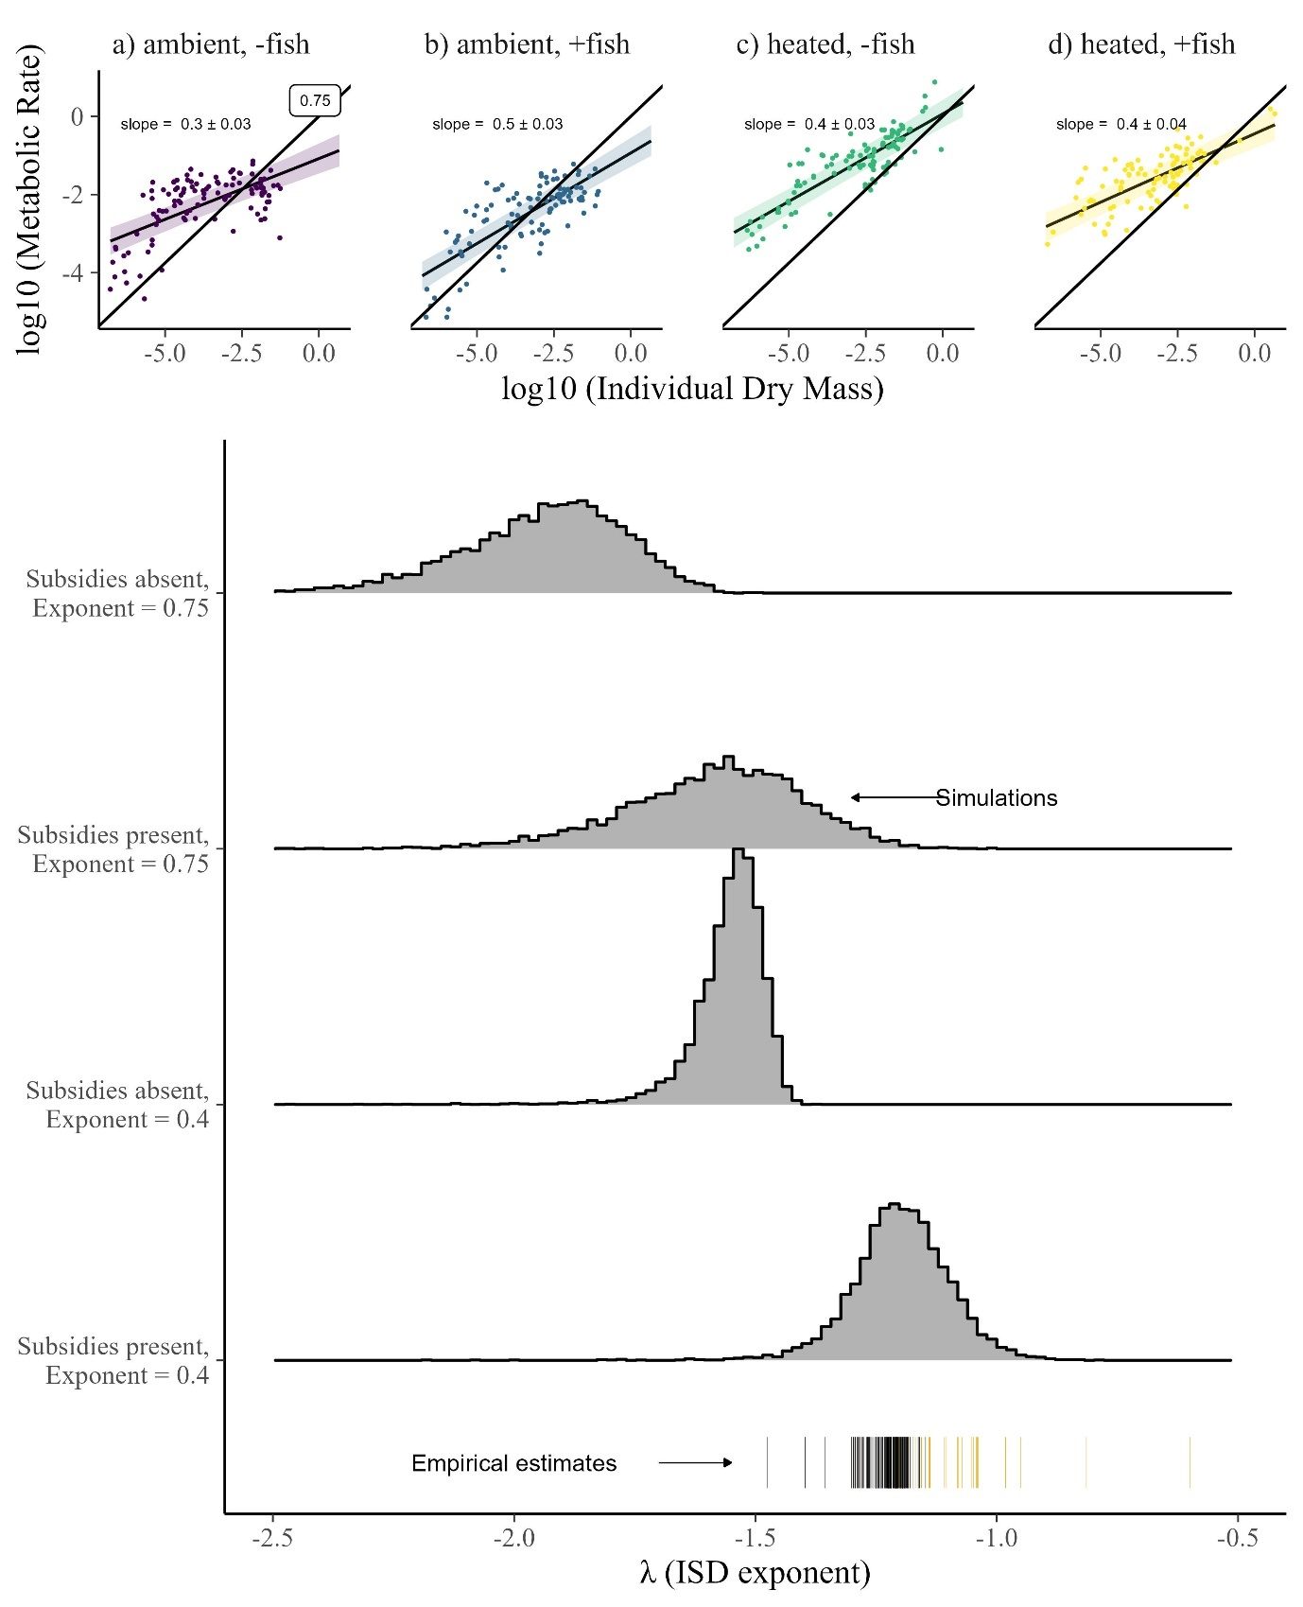

**Fig. 6 | Shallow metabolic-mass scaling in freshwater insects and simulations of lambda.** a-d. Metabolic-mass scaling of 412 larval aquatic insects measured under four experimental conditions in stream mesocosms (ambient temperatures without fish, ambient temperatures with fish, heated (+4C) without fish, and heated (+4C) with fish. Temperature increased overall metabolic rates, but did not alter metabolic-mass scaling, which averaged 0.4±0.07 (posterior mean ± sd), substantially shallower than 0.75 (black reference line). e. Lamda estimates from stochastic simulations using either 0.75 or 0.4 metabolism-mass scaling (with added uncertainty), along with literature estimates of subsidy effects, PPMR, and TE (and their uncertainty). Comparing simulations to empirical estimates (black: 133 NEON field estimates; orange: 24 stream mesocosm estimates) shows that only conditions with subsidy effects and shallow scaling produce lambdas measured in streams.